Ref. No: Date: 29/11/2023

Notice Regarding revised 5th Semester PROGRAMME Internal exam
It is hereby notify to all students of 5th semester PROGRAMME that an internal exam will be held on 18/12/2023 (Monday) at room no 304. The examination will be start exactly from 11:30 am. All must come with pen, writing board and old admit card. No excuse will be entertained. If anyone fail to attend, he/she will be treated as absent in that examination.

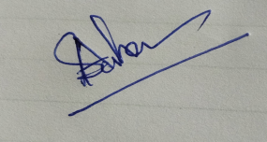
HOD
Department of Chemistry

